**Lab 3.2: Putting opamps to ‘gainful’ use [POSITIVE Feedback]**

**Conceptual introduction**

The prototype design for an opamp circuit using positive feedback is shown below in Fig 1

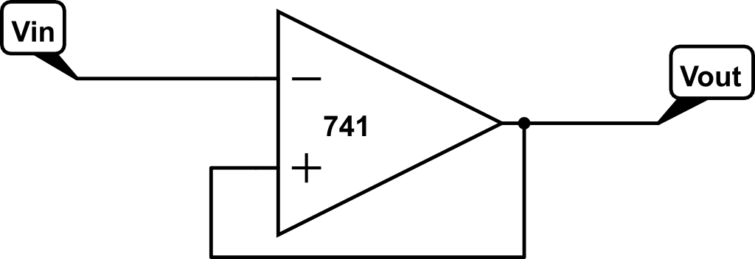

Fig 1: Prototype showing essential features of a positive feedback circuit. Fraction is send as feedback to the terminal

The two defining features of a positive feedback circuit are:

**1)** feedback signal is **always** applied to the terminal

**2)**  can have only two values - : these are the two states of the output – we will refer to the output ‘switching’ between these two states. is the maximum saturation voltage of the opamp output, usually a volt or so less than

The two Golden Rules of opamp design are obviously still applicable and all analysis is done on the basis of those two rules.

**1) Circuit design**

**Problem statement:**   
**What we DON’T want:** Opamp running open-loop acts a comparator.   
In Fig 1, consider what happens when the circuit in Fig 1 does not have the feedback loop in place. If ( i.e. is set to GND (and disconnected from , breaking the feedback connection) then, will switch states when transitions from and vice versa. However, as we know voltages are always noisy! So a small noise fluctuation in around transition threshold will cause the output to switch multiple times.   
With your kit’s current battery state (maybe much less than 9V!) check the Vsat values you get with opamp open-loop comparator – most of the calculations below will depend on the numerimcal Vsat  
  
**WHAT WE WANT:** Design a circuit that is called a **“Schmitt Trigger”**   
The problem with noisy Vin and the desired solution for behavior of Vout is shown in Fig 2

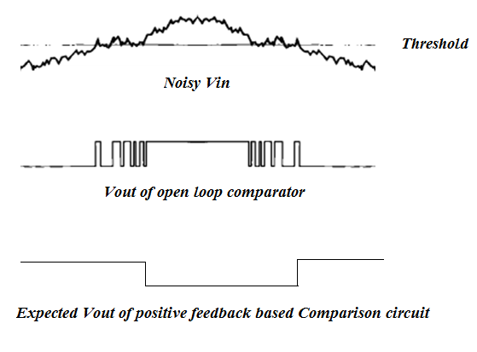

Fig 2: of open loop comparator switches many times as noisy crosses threshold.   
**OBJECTIVE:** Should be able to set a specified value of threshold voltage and have a specified safety ‘noise’ band around the threshold (marked as blue shaded box):   
**Required circuit:** must switch only when exits that safety band.  
**Note:** Timing & logic of the transitions highlighted above are caused by the intrinsic structure of our **inverting** Schmitt trigger.

**Design specification:**

As per Figures 1 and 2, design a positive feedback circuit using the LM741 such that:

1. Threshold Voltage
2. Noise band allowed around
3. Use regular opamp power supply setup as earlier don’t forget the power supply bypass caps!

**Hints for design:**

1. As in negative feedback the fraction is set by a resistor divider. However, now our analysis is constrained by Vout being stuck to ±Vsat and having to set **two** bounds on the comparison :   
   both and   
   For simplicity we have asked for a symmetrical noise band around . In principle it is possible to set different lower and upper bounds around
2. You will find THREE resistors are required instead of two as used in the negative feedback case.
3. Generally, such a circuit is called a ‘Schmitt Trigger’

**Solution to Question 1) 5**

Put a sketch of your Schmitt Trigger design here labelling the resistors and the design calculation equations that fulfill the required specifications.

(can be photo of hand-drawn sketch). Equations must be properly formatted

We have,

Where R = R1||R2||R3 and Vcc = Vsat = 8V

We equate

On solving these, we get

R3 can be chosen to be 6.8kΩ. Therefore, R1 = 47kΩ and R2 = 2.2kΩ

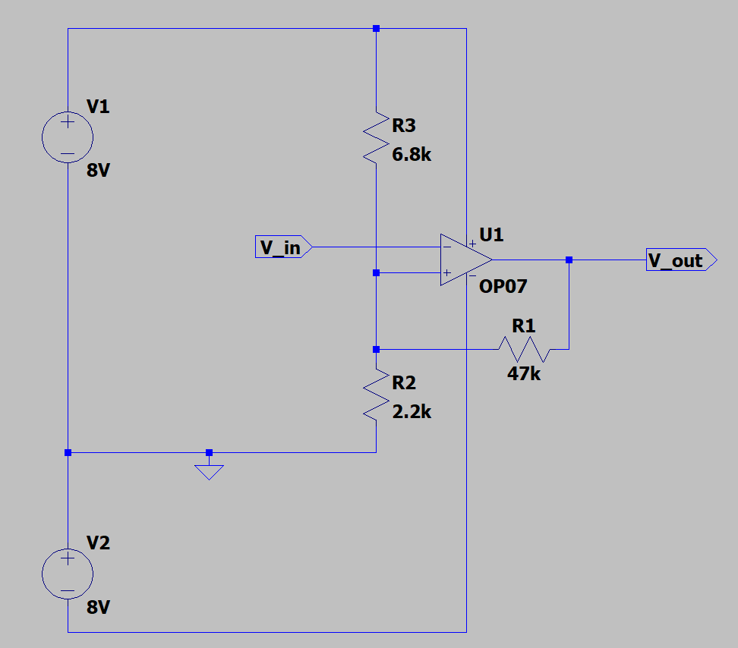

**2) Simulation 5**

Simulate the circuit in LTSpice. For Vin Use the full-scale output of your standard square waveform from FG’s collector of transistor Q3. Normally, the square wave output of the FG swings 0V to slightly less than VCC.   
Simulation will give a very fast transition across the threshold voltage. But note that in the next question, when you do the circuit test the actual VCC may be much lesser, and Vin will be quite a bit noisier!

Circuit diagram **2 marks**

Plot of Vout & V+ (time domain) **1 mark**

Plot of Vout v/s Vin **2 marks (notice the hysteresis behavior!)**

**Circuit Diagram**

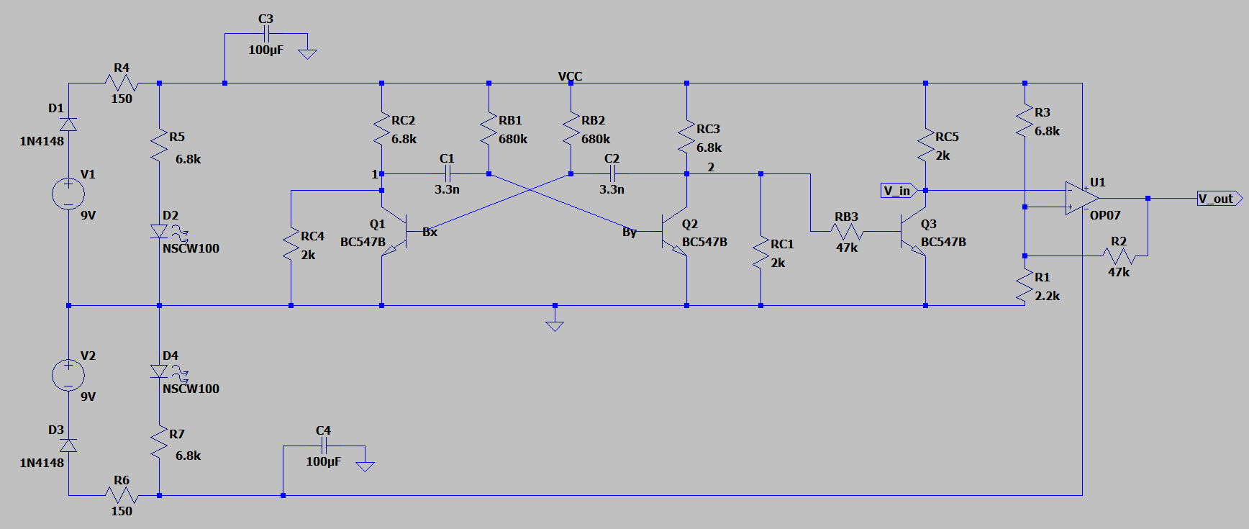

**Vout vs time**

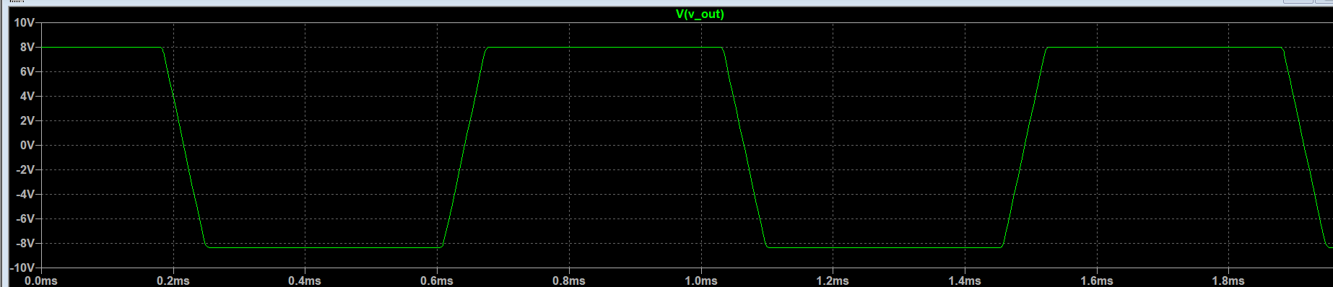

**V+ vs time**

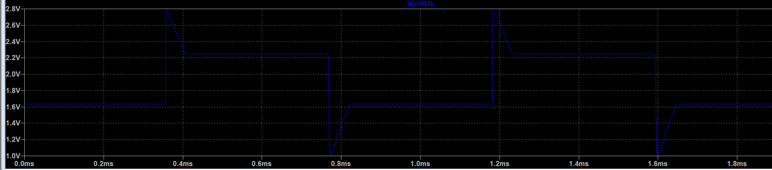

**Vout vs Vin**

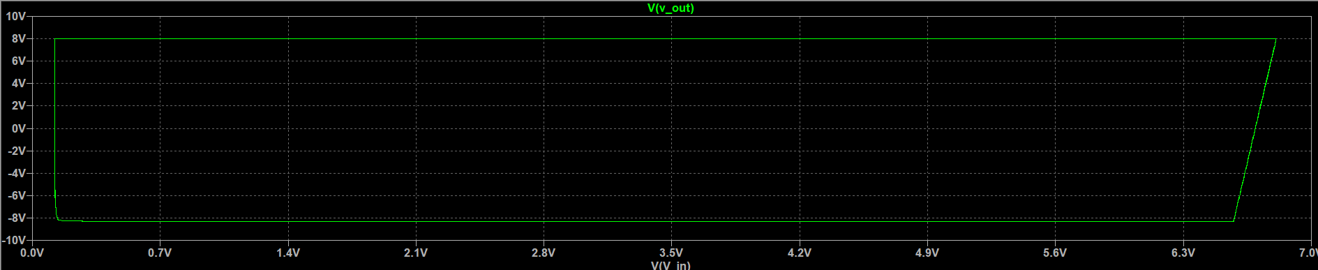

**3) Circuit test – electrical voltages 5**

Build the Schmitt trigger circuit designed and simulated on your breadboard.

Do a photogenic demo of your V+ and the Vout of your Schmitt trigger. Label each photo to distinguish which is which.  
Use the full scale square wave output from FG as Vin

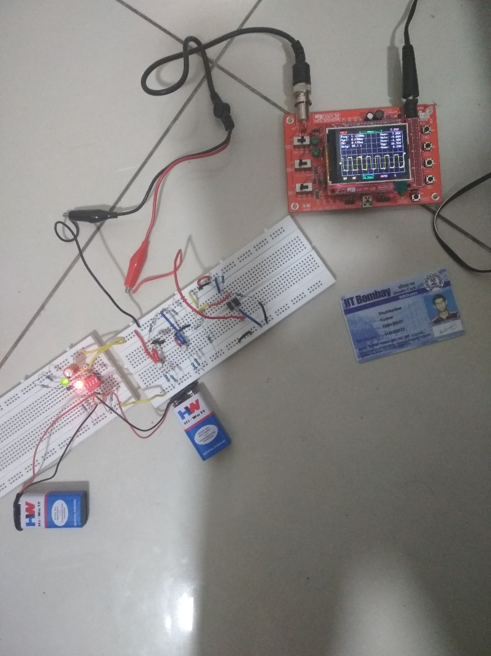

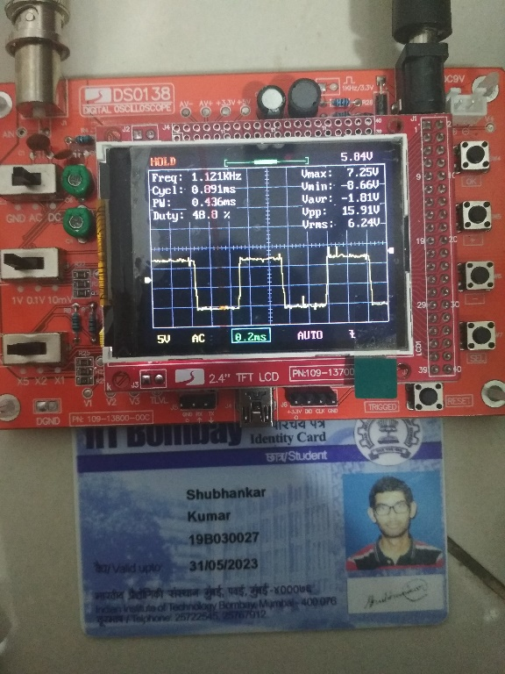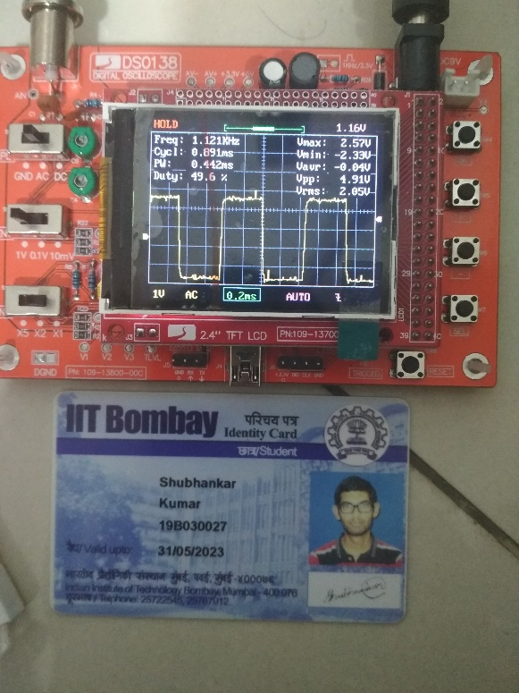

**Vout  V+**

**4) Circuit test – noisy light intensity measurement 10**

Now we would like to test the Schmitt trigger with a realistic, noisy sensor voltage input.

**Sensor:** Setup the photo-transistor in your kit as a light detector. With the base left unconnected, the voltage obtained at the emitter is proportional to the light incident on the device

**Light source:** Use an LED connected to the FG output with a suitable series resistor to provide a variable light intensity to your sensor photo-transistor. Note that the LED and photo-transistor must be mounted facing each other on the breadboard as close to each other as possible. The LED has ≈ 60° cone of light emission and the phototransistor also has maximum sensitivity within a 60° cone as shown below.

Breadboard

LED

SENSOR

60°

60°

Ambient light introduces noise!

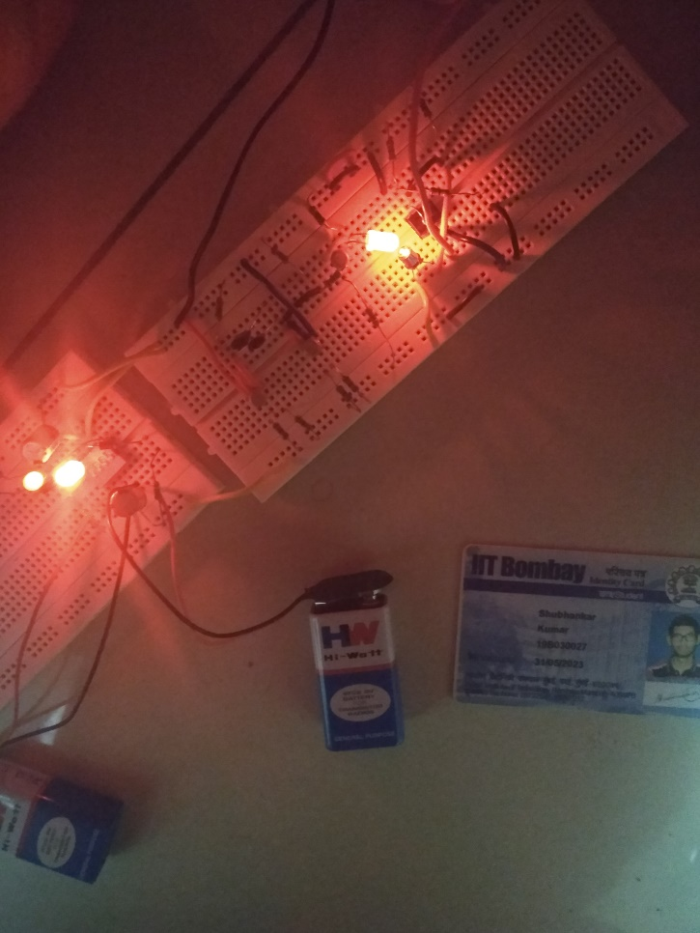

**(next page)**

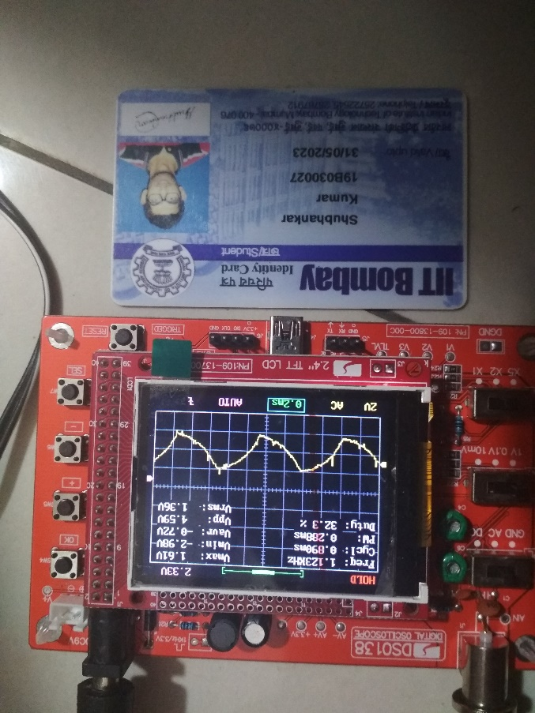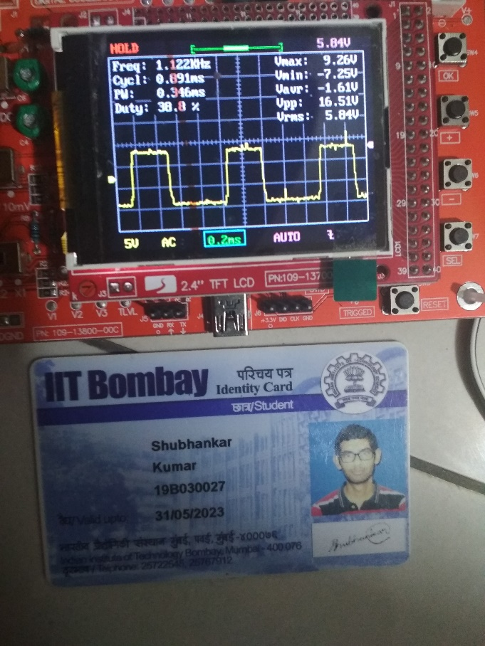

**Vin Vout**

We observe that the voltage waveform from the phototransistor happens to be a sawtooth wave. The output waveform from the op amp due to the Schmitt trigger will be a square wave (as shown in the right figure).